|  |  |  |  |  |  |
| --- | --- | --- | --- | --- | --- |
| Date | 12-Dec-22 | | | Tester Name | Mayuri Patel |
| Environment | Penfax - Test | | | Login used |  |
| Operating System | Select OS | Version: | Update: | | |
| Software Used | Select Software | Version: | Update: | | |
| Select Software | Version: | Update: | | |
| Release version | 22.4.1 | | | | |
| Title |  | | | | |
| Test Type | Regression | | | | |
| Test Scenario | Process PEPP Accounts Payable Payment Report | | | | |
|  |  | | | | |
| Expected Results |  | | | | |
| Pass/Fail | Pass | | | JIRA# | N/A |

Describe your steps with screenshots:

Go to Batch Processes

Enter Batch Process Type to Clear Accounts Payable and Search

Select the recent Batch Process ID

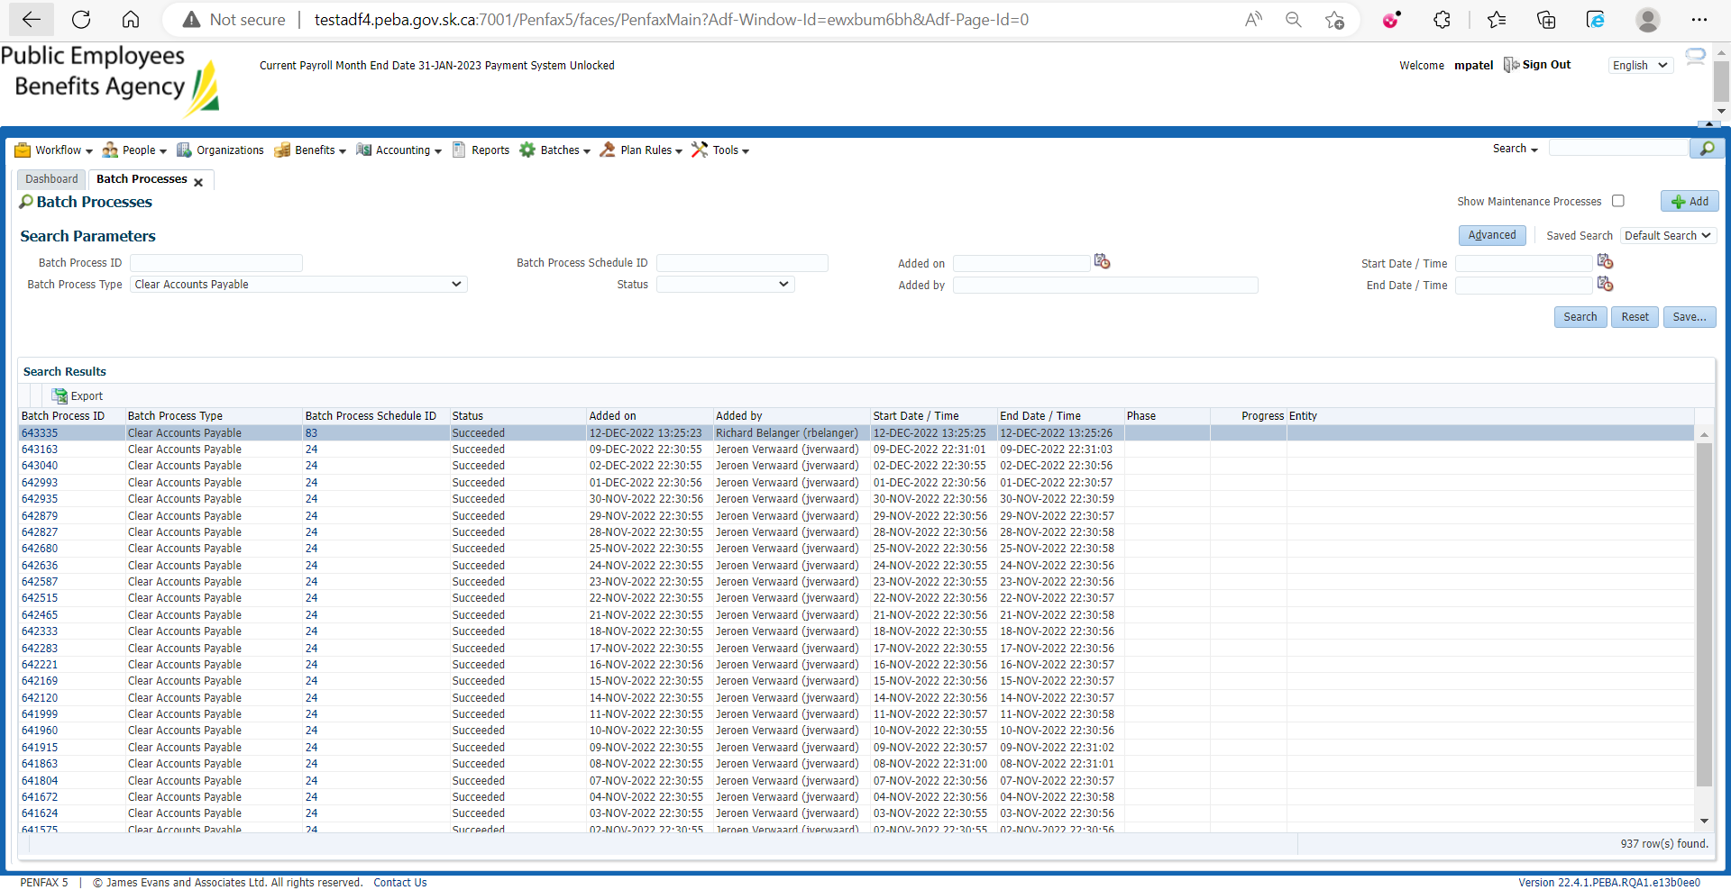

Under Files tab Accounts Payable Report is there

Download and Open that Report

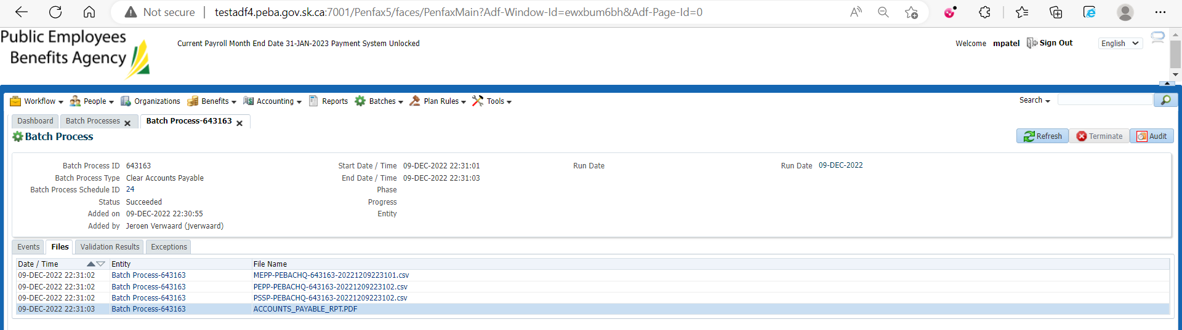

Opened Accounts Payable Payment Report

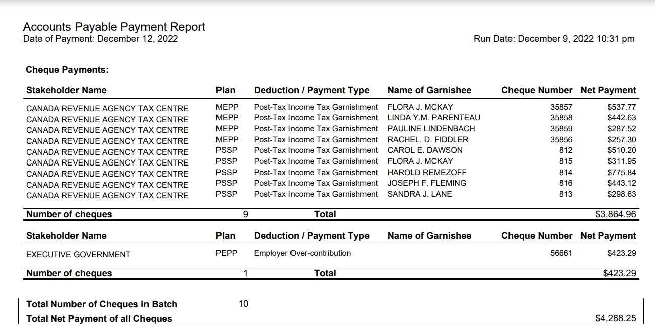

To Verify the Report, Go to Cheque Search

Enter Cheque number and plan from the report and verify the details

Likewise do the same for all other cheques

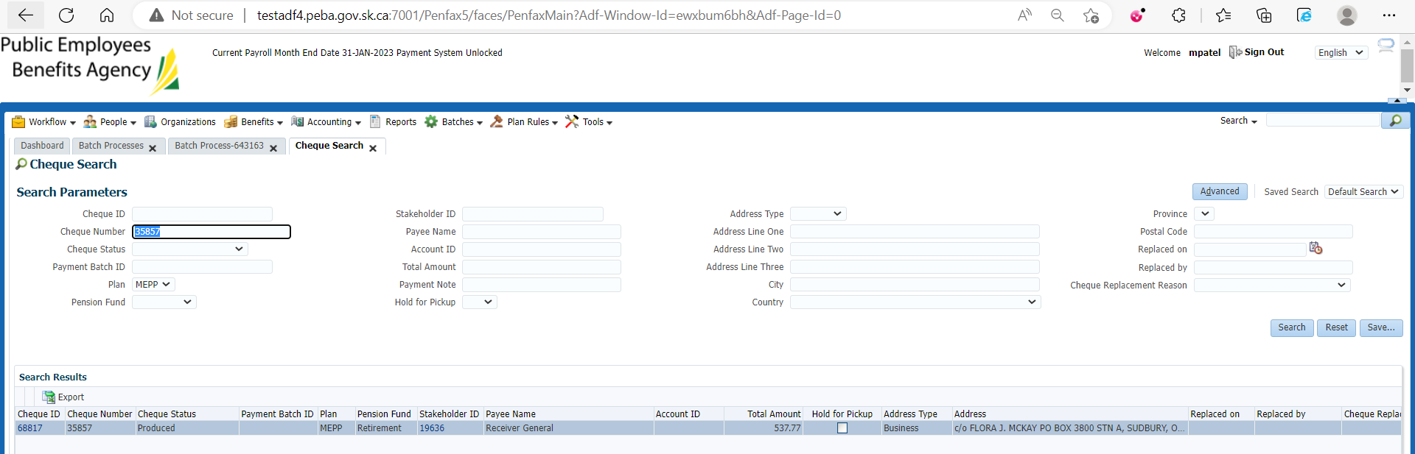

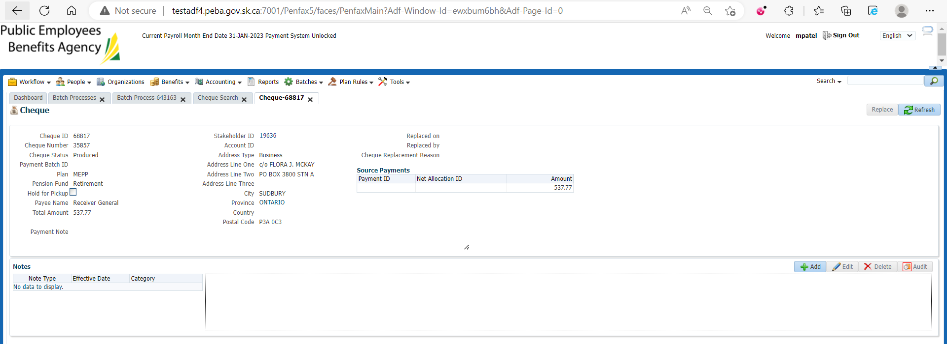

Accounts Payable Payment report is saved at H:\Quality Assurance\Prod Apps\Testing Management\Regression Testing\Nov 2022 - PENFAX 22.4.1 Release\PEPP\Test Results\E15 Reports